

**Getting Started Guide for  
Windows® Home Server 2011**

**Abstract**

A Getting Started Guide introducing the new features, providing installation instructions and providing a detailed overview of the features and functionality of Windows® Home Server 2011.

Information in this document is subject to change without notice. The example companies, organizations, products, people, and events depicted herein are fictitious. No association with any real company, organization, product, person or event is intended or should be inferred. Complying with all applicable copyright laws is the responsibility of the user. Without limiting the rights under copyright, no part of this document may be reproduced, stored in or introduced into a retrieval system, or transmitted in any form or by any means (electronic, mechanical, photocopying, recording, or otherwise), or for any purpose, without the express written permission of Microsoft Corporation.

Microsoft may have patents, patent applications, trademarked, copyrights, or other intellectual property rights covering subject matter in this document. Except as expressly provided in any written license agreement from Microsoft, the furnishing of this document does not give you any license to these patents, trademarks, copyrights, or other intellectual property.

Microsoft Corporation. All rights reserved.

The example companies, organizations, products, domain names, e-mail addresses, logos, people, places, and events depicted herein are fictitious. No association with any real company, organization, product, domain name, e-mail address, logo, person, place, or event is intended or should be inferred.

Microsoft, Windows, Windows Live, the Windows logo, and Windows Server are either registered trademarks or trademarks of Microsoft Corporation in the U.S.A. and/or other countries.

Other product and company names herein may be the trademarks of their respective owners.

Last Updated: **July 2011**

Table of Contents

[What’s New 4](#_Toc298324482)

[Remote Access 4](#_Toc298324483)

[Remote Streaming 4](#_Toc298324484)

[Personalize your Remote Access Page 4](#_Toc298324485)

[Connecting to your Media 4](#_Toc298324486)

[Home Media Streaming and “Play To” 4](#_Toc298324487)

[HomeGroup Support 4](#_Toc298324488)

[More Streaming Support 5](#_Toc298324489)

[Windows Phone 5](#_Toc298324490)

[Streaming Content 5](#_Toc298324491)

[Sharing Content 5](#_Toc298324492)

[Monitoring Alerts 5](#_Toc298324493)

[Protecting Devices 5](#_Toc298324494)

[Live Tile Support 6](#_Toc298324495)

[Computers and Backup 6](#_Toc298324496)

[Backup the Backups 6](#_Toc298324497)

[Computer Backup Archiving 6](#_Toc298324498)

[Macintosh 6](#_Toc298324499)

[Storage 6](#_Toc298324500)

[Shared Folder Data Migration 6](#_Toc298324501)

[Previous Versions 6](#_Toc298324502)

[The Dashboard, Launchpad, and Extensibility 7](#_Toc298324503)

[Better Control 7](#_Toc298324504)

[Easier Setup 7](#_Toc298324505)

[Easier to Access 7](#_Toc298324506)

[Extensibility and Add-ins 7](#_Toc298324507)

[System Requirements 9](#_Toc298324508)

[Setup and configuration 10](#_Toc298324509)

[Installing the Windows Home Server Connector Software 10](#_Toc298324510)

[Feature Details 11](#_Toc298324511)

[Home Computer Backup and Restore 11](#_Toc298324512)

[Home Server Backup and Restore 12](#_Toc298324513)

[Shared Folders and Server Storage 13](#_Toc298324514)

[Media Streaming 14](#_Toc298324515)

[Remote Access 15](#_Toc298324516)

[Home Network Health Monitoring 18](#_Toc298324517)

[Windows Home Server 2011 Dashboard 18](#_Toc298324518)

[Partner Add-ins 19](#_Toc298324519)

[Resources 21](#_Toc298324520)

[Public Resources 21](#_Toc298324521)

[Windows Home Server blog: 21](#_Toc298324522)

[Windows Home Server public forums: 21](#_Toc298324523)

[Installation Instructions: 21](#_Toc298324524)

# What’s New

Windows Home Server 2011 is the version 2 release of Windows Home Server. Windows Home Server 2011 is based on Windows Server® 2008 R2.

## Remote Access

Remote Access is now based on Silverlight® and has a higher degree of extensibility in the software development kit (SDK), allowing for more customization, gadgets, add-in extensions, mobile rendering and an improved shared folder experience with AJAX support.

### Remote Streaming

One of the most exciting new features of Windows Home Server 2011 is an enhancement to Remote Access that enables remote streaming of your media through the Internet so you can access your multimedia virtually anywhere, anytime you’re online. Now you can watch your family videos or view your birthday photos from outside your home without having to download your content first.

**Supported Formats:**  
MPEG-2, MPEG-1, WMV/VC-1, AVI, DVR-MS, H.264/MPEG-4 AVC, WMA, MPEG-1 Layer 3, WAV, LPCM, AAC, JPEG, PNG, RAW

**Supported Extensions:**.mpeg, .mpg, .wmv, .avi, .drv-ms, .mp4, .wma, .mp3, .wav, .m4a, .m4h, .mp4, .jpg, .png

### Personalize your Remote Access Page

Windows Home Server 2011 enables you to customize the default picture, Web site logo and even add links to other Web sites on your home page, so you can personalize the experience that friends and family see when they visit your site.

## Connecting to your Media

### Home Media Streaming and “Play To”

A lot of devices on the US market today are DLNA [(Digital Living Network Alliance)](http://go.microsoft.com/fwlink/?linkid=189001) compatible. DLNA enables your home server to participate in a “Play To” environment as a Digital Media Server (DMS). Other DLNA-compatible devices--TVs, stereos, your Xbox 360® and more—can automatically find your home server from within your home network and then stream videos, music and pictures on demand from it.

### HomeGroup Support

[HomeGroup](http://go.microsoft.com/fwlink/?linkid=177709) is a feature of Windows 7 that simplifies the process of sharing files and printers on a home network. You can print documents from almost anywhere in the house. Adding Windows Home Server 2011 to your HomeGroup makes it simple to have a centralized place where you can store all your documents, files, and digital media content. Unlike other computers, the home server is designed to be always on, so you do not have to worry about it being shut off, disconnecting you from its resources.

### More Streaming Support

Windows Home Server 2011 has a broader range of codec support, giving you the ability to stream a broader range of content than the previous version. If content is not playable to a device, your home server will transcode the video and audio files to different formats and resolutions on the fly to assist in making the content playable.

## Windows Phone

The Windows Phone app, **My Home Server**, needs to be installed on the Windows Phone in order for these features to work. “My Home Server” app is available through the Windows Phone Marketplace and the home server add-in is available through [Microsoft Download Center](http://go.microsoft.com/fwlink/?LinkId=214671).

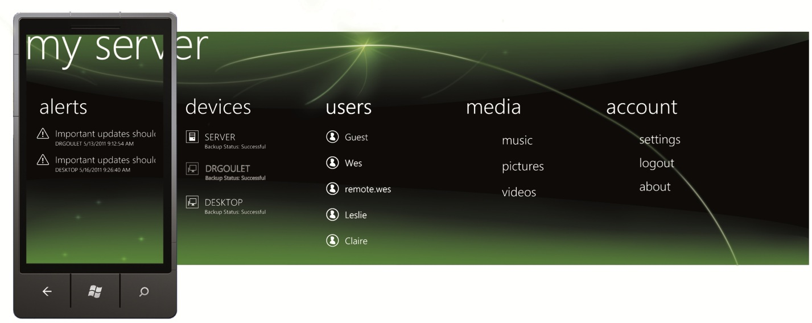

### Streaming Content

Your videos, photos and music are no longer limited to your home entertainment system and your remote PC. Windows Phone 7 now can stream your content from your Windows Home Server 2011 right to the palm of your hand. Plug your phone into your car stereo and listen to your home collection on the road or show your home video to friends and family in a restaurant. As your music, video and photo collections grow, you are no longer limited to the storage on your Windows Phone.

### Sharing Content

Sharing with Windows Phone is simple but now it’s more powerful! A new option enabled by Windows Home Server 2011 allows you to upload photos to your shared folders, remotely. Once the photos are uploaded, they are still accessible by your phone, even when you’re away from home.

### Monitoring Alerts

The home administrator can now verify problems inside their home network from alert notifications. Many notifications offer the ability to try and repair. Along with trying to repair option, you can disable or enable an alert.

### Protecting Devices

Knowing your home computers are safe and backed up is often a great piece of mind. The My Home Server app provides you with the power to check the status of your PCs and Macs, and start or stop a backup while you are away from home!

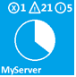Live Tile Support  
If you pin the application to the home screen of your Windows Phone 7, you will be able to see a variety of at-a-glance information without launching into the application. Quickly understand how many health alerts are pending and the percentage of storage space available on your Windows Home Server.

## Computers and Backup

### Backup the Backups

A popularly requested feature for Windows Home Server, being able to create a backup of the client PC backup database, has arrived with Windows Home Server 2011. This allows you to incorporate the backups of your PCs in your server protection strategy, including storing them offsite.

### Computer Backup Archiving

If you are replacing an old computer with a new computer and you’d like to keep the old computer’s backups, Windows Home Server 2011 provides an archiving feature. When removing the Windows Home Server Connector software from the old PC, you will be asked if you’d like to keep the backups for this computer on the server. Computers that are archived are not part of the 10 computer backup limit.

## Macintosh

Windows Home Server 2011 now supports joining Macintosh OSx to the server giving Macintosh users that ability to use Launchpad. The Macintosh Launchpad enables quick and easy access to TimeMachine ®, Remote Web Access and 3rd party applications. Now that your Macintosh is joined to the home server, your worries about data loss are over! With TimeMachine ® as the interface, you are able to setup automatic backups and even restore files!

## Storage

### Shared Folder Data Migration

Control over your data is very important and moving it has never been easier. The “Move the folder” wizard provides the ability to shift your data from one server hard drive to another should a drive become full. This replaces the need to move content manually and allows centralized control over your home server through the Dashboard.

### Previous Versions

Some changes to your shared folders are not always wanted changes. Previous versions allow you to go back in time before an unwanted alteration occurred and recover files which were accidently deleted. Previous versions are separate from home server backups and also automatically occur twice a day. When enabled, any file or folder on the enabled storage drive, are available for restore from alterations. Home server backup is still recommended in the case of hardware failure.

## The Dashboard, Launchpad, and Extensibility

### Better Control

The Dashboard, which replaces and enhances the Windows Home Server Console, is the command and control center for Windows Home Server 2011. From the Dashboard, you can perform all the management and maintenance tasks you need to control how your home server behaves on your network, who can access it, what information can be stored and retrieved, how it is organized, protected, streamed, and made available remotely. The Dashboard itself can be accessed remotely by users who have permission.

Like the Console it replaces, the Dashboard is organized around tasks that you may wish to perform, with different activities presented on different tabs. Each tab in the Dashboard contains more properties, giving you better control, while still making changes simple to understand and perform.

### Easier Setup

For each home computer you want to fully participate in a Windows Home Server network, you install the Windows Home Server Connector software on it. In earlier versions of Windows Home Server, the Connector software came on a CD. With Windows Home Server 2011, there is now an easy-to-remember link to install the Connector software, http://<servername>/Connect, where <servername> is the name you give your home server. Having a Web-based setup for your home computers means never having to find your CDs.

### Easier to Access

The Launchpad, which runs on each client PC in your home network, provides a simple way for everyone in your home who has the appropriate permissions to access your Shared Folders, initiate a backup, connect to your Remote Access page, or open the Dashboard.

### Extensibility and Add-ins

One of the most popular aspects of the first version of Windows Home Server was the rich collection of add-ins developed by commercial partners and enthusiast developers that further extend and enhance the functionality of the home server. Several improvements were made to the SDK to help developers continue to build applications for Windows Home Server 2011. Some of the new capabilities include:

* Dashboard Extensibility :
  + Add high level Dashboard Tab/tabs
  + Your own high level tab can contain sub tabs
  + Tabs / Sub tabs can be of the following different types:
    - List View tabs/sub tabs: add-ins have the option not to use custom UI, but instead use the rendered common list view UI with many extensible parts. This allows users to enjoy a common look and feel regardless of who developed the add-in
    - Custom control tabs/sub tabs: Custom control tabs can be Winforms based OR WPF ( Windows Presentation Foundation) based
  + Default Tabs are extensible – the SDK will walk you through them
    - Add your own sub tabs under these tabs
    - Add more data to the existing tabs, such as task, columns, details
  + Home page is extensible: Add common tasks and community links
* Launchpad Extensibility:
  + Add categories and tasks to the Launchpad
* Remote Access Website extensibility:
  + You can add your own link in an online services section, create a new item in the menu bar, create a new gadget for the home page
* A new framework called the “Provider Framework” is an architectural layer that performs all the business data processing and holds state for each feature. The SDK will help you build your own set of providers
* Certain wizards and property pages are also extensible
* Samples and templates are included to help add-in developers
* A helpful “How-to” section provides walkthroughs of several common extensibility scenarios
  + The extensibility scenarios use the templates to create meaningful sample code that run on Windows Home Server 2011

# System Requirements

* Windows Home Server 2011 is a 64-bit only operating system
* You can install the server software either manually or unattended, although in the vast majority of cases it will come pre-installed on OEM hardware
* System requirements:
  + CPU Socket (1 Socket Max)
    - 1 - 1.4 GHz (64-bit processor) or faster for single core
    - 1 - 1.3 GHz or faster for multi-core
  + Memory (RAM)
    - Min - 2 GB
    - Max – 8 GB
  + Storage
    - At least one 160 GB (or larger) hard drive for OS and initial data drive
    - Additional hard disks may be included to store data
* Supported networking configuration:

1. Your server computer must be connected to a router via a network cable
2. The router works best with a UPnP ™ certified device, but it is not required
3. The router works best in the 192.168.x.x subnet, but it is not required

|  |
| --- |
|  |

# Setup and configuration

For detailed instructions about installing Windows Home Server 2011, see the Windows Home Server 2011 Release Notes on the Windows Home Server 2011 online help site <http://go.microsoft.com/FWLink/?LinkID=165674>.

## Installing the Windows Home Server Connector Software

The Windows Home Server Connector software does the following:

• Connects your home computer to Windows Home Server 2011

• Automatically backs up your home computer nightly

• Monitors the health of your home computer

• Enables you to configure and remotely administer Windows Home Server 2011 from your home computer by using the Dashboard

The following operating systems for home computers are supported to work with Windows Home Server 2011:

**The Windows 7 Operating System**

* Windows 7 Home Basic (x86 and x64)
* Windows 7 Home Premium (x86 and x64)
* Windows 7 Professional (x86 and x64)
* Windows 7 Ultimate (x86 and x64)
* Windows 7 Enterprise (x86 and x64)
* Windows 7 Starter (x86)

**The Windows Vista Operating System**

* Windows Vista Home Basic with Service Pack 2 (SP2) (x86 and x64)
* Windows Vista Home Premium with SP2 (x86 and x64)
* Windows Vista Business with SP2 (x86 and x64)
* Windows Vista Ultimate with SP2 (x86 and x64)
* Windows Vista Enterprise with SP2 (x86 and x64)
* Windows Vista Starter with SP2 (x86)

**The Windows XP Operating System**

* Windows XP Home with Service Pack 3 (SP3)
* Windows XP Professional with SP3
* Windows XP Media Center Edition 2005 with SP3

To install the Windows Home Server Connector software

|  |
| --- |
| 1. Open a Web browser, type http://<ServerName>/connect or http://<ServerIPv4Address>/connect in the address bar, and then click ENTER.  Note  If you have problems connecting to the server in the Web browser, click Start, click Computer, double-click Network, and then double-click the server name in the Other Devices section.  2. Click Connect your computer to the server, and then click Run  3. On the User Account Control box, click Yes  4. Complete the wizard to connect your computer to Windows Home Server 2011.  • To administer the server, open the Windows Home Server 2011 Dashboard, type the server password, and then click the arrow  • To access the your shared files, start backing up for your home computer, or use Remote Access, open the Launchpad, type a valid user name and password, and then click the arrow |

Run the Windows Home Server Connector wizard on all of your other home computers to connect them to Windows Home Server 2011. Run the wizard on one computer at a time.

# Feature Details

## Home Computer Backup and Restore

Windows Home Server 2011 automatically backs up your home computers to the home server and can help you easily restore the entire computer or an individual file or folder to a previous point in time. The WindowsHome Server Backup solution uses an innovative method to back up only the data that has not already been backed up before. Even if you have several copies of the same data on different computers, the data is backed up only once on your home server, and your home server keeps track of what data was stored on each home computer on each day. Backups complete quickly and efficiently, and use less space on your home server.

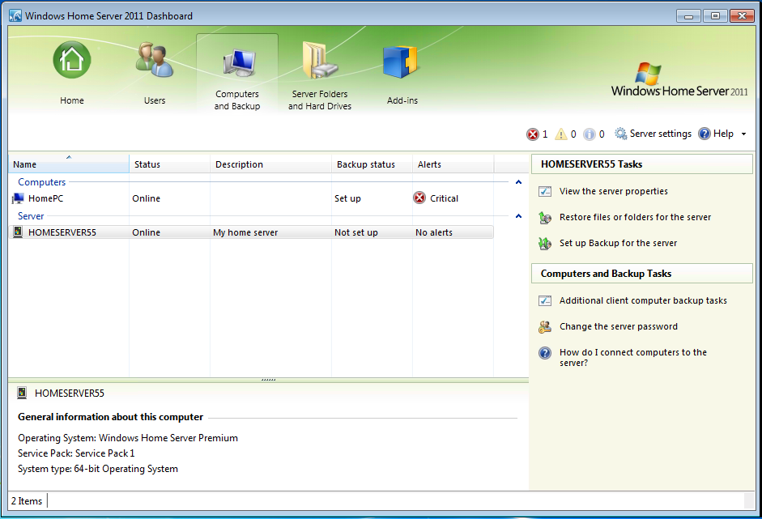

•    **Automated Daily Backup of your Home Computers**

Computer backups are automatically configured when you install the Windows Home Server 2011 Connector software on your computers. Backup is performed on a daily basis for every configured computer.

• **Help Restore an Entire Home Computer**

Restoring a home computer to a previous point in time is easy. If you want to restore your computer to a previous point in time, you boot the home computer from the Home Computer Restore CD. The computer connects to your home server, which provides a simple wizard for restoring a single hard drive or multiple hard drives from a backup of that computer that is stored on your home server.

• **Help Restore Individual Files and Folders**

Windows Home Server 2011 can help you restore individual files or folders by selecting a home computer and a specific backup of that computer from the Dashboard. The Restore Wizard initiates and displays the files and folders that were backed up for that computer on that day. You can easily select individual files or entire folders from this Restore Window and then restore them to any location on your home computer.

## Home Server Backup and Restore

Windows Home Server 2011 helps you back up its Shared Folders to external drives. This feature gives you the ability to take your files offsite and easily restore them later, so they are stored at an alternate location in case of fire damage, theft, or other catastrophe to your primary computer. In case of accidental data loss, you can simply restore a file from your home server backup. You can add a hard disk drive, either internally or externally to the device, and designate it as a backup destination as opposed to server storage. Windows Home Server 2011 will then use this drive to back up all the data stored on the server. Using multiple external drives makes it easy to rotate your backups offsite, to maximize availability of backups in case of theft, fire, flood, and other disasters in relation to your primary computer.

## Shared Folders and Server Storage

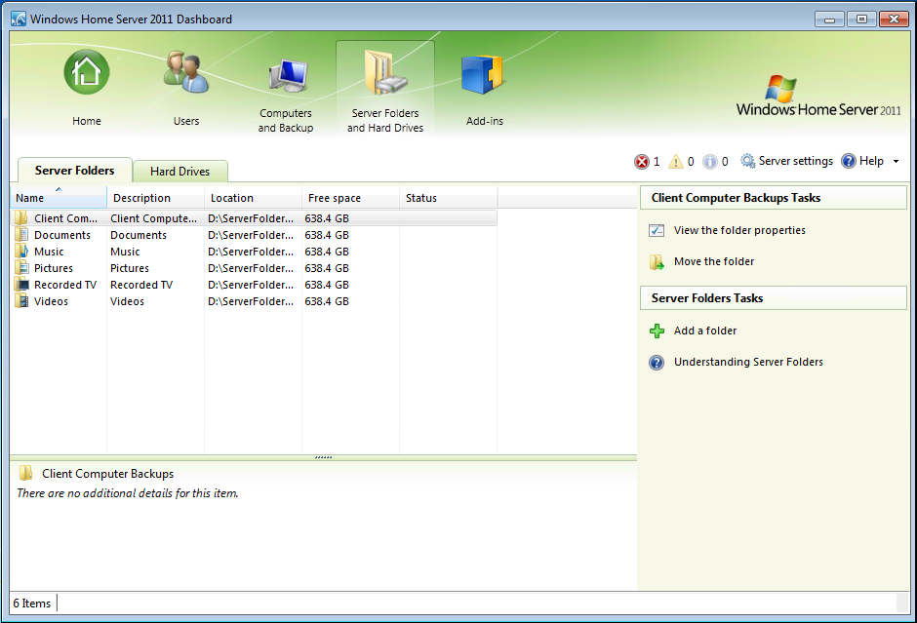

•     **Pre-Defined Shared Folders**

Your home server is pre-configured with the following shared folders: Pictures, Music, Videos, Documents, Recorded TV and Users. From the Windows Home Server 2011 Dashboard you can specify the user permissions for these folders and create a number of new shared folders.

• **Easy to Add More Storage**

From the Windows Home Server 2011 Dashboard you can format new uninitialized hard drives using a simple wizard. As you add formatted drives, you can move your shared folders to specific storage device using the “Move the folder” wizard. We recommend using external hard drives for backups only, and keeping all data and server folders on internal hard drives since external hard drives can easily disconnected.

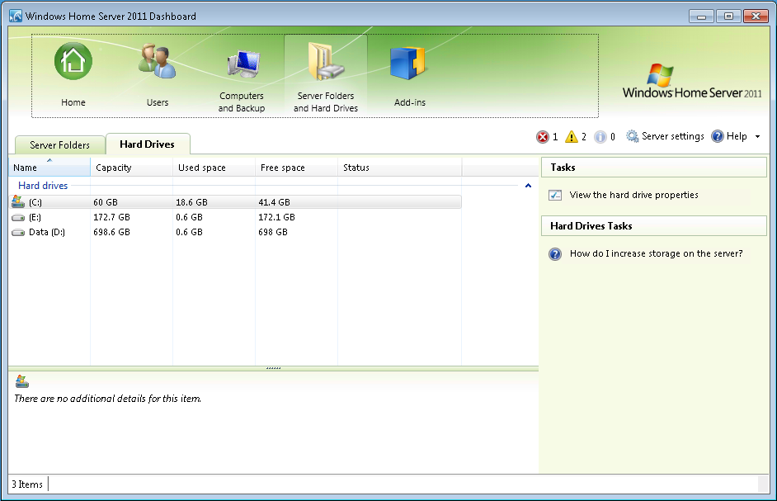

• **Shared Folder Previous Versions**

Previous versions are enabled by default but can be disabled/enabled manually through the Server Folders and Hard Drives tab. Opening a hard drive’s properties will display “Shadow Copy” options. Shadow Copies is the technology that enables the use of previous versions on the shared folders. Previous versions can be accessed from any authorized user by right clicking the file or folder inside the shared folders. From the Previous Version’s tab, you can restore, copy or open the previous version.

## Media Streaming

Your home server is pre-configured with the following shared folders that can be used to store your media files and are, by default, enabled to stream: Pictures, Music, Videos and Recorded TV. You can enable newly created shared folders to stream at any time by including them in the media library using the Windows Home Server 2011 Dashboard. You can selectively include any shared folder in the media library, so that your music, pictures and/or videos can be accessible from an Xbox 360 entertainment system or another supported digital media receiver that is attached to your home network. Your content will also be available for Play To. TV Archive is installed with the Windows Home Server Connector software and libraries are automatically added to the Windows Media Center PC, allowing your shared content to be visible from Windows Media Center and its extenders.

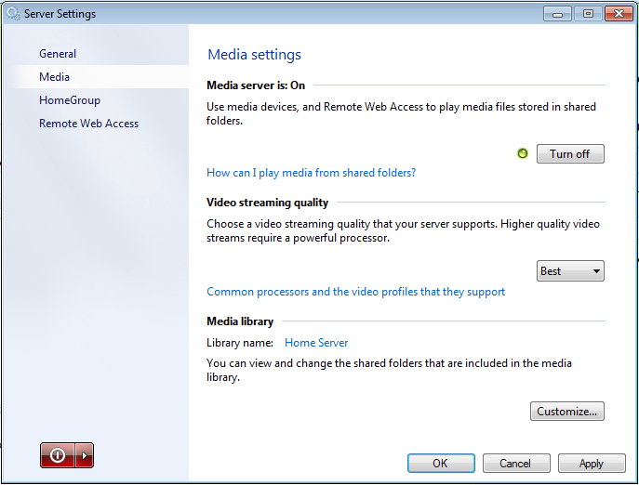

* **View Photo Slideshows from a Home PC**

You can store your digital photos in the Pictures shared folder on your home server so you can access them from your home computers or from an Xbox 360 in your home.

* **Stream Music in your Home**

Similarly, you can store your music on your home server so you can access and play it from your home computers or a digital music receiver on your home network.

* **Store your Videos on your Home Server**

Your home server can be used to store your collections of videos and recorded TV from a computer running Windows Media Center. Windows Media Center Extenders can also access the video, music and picture content on your home server.

## Remote Access

After you have turned Remote Access on and configured a user account for Remote Access using the Windows Home Server 2011 Dashboard, you can use a supported web browser on a computer from outside your home to access your home server and home computers remotely.

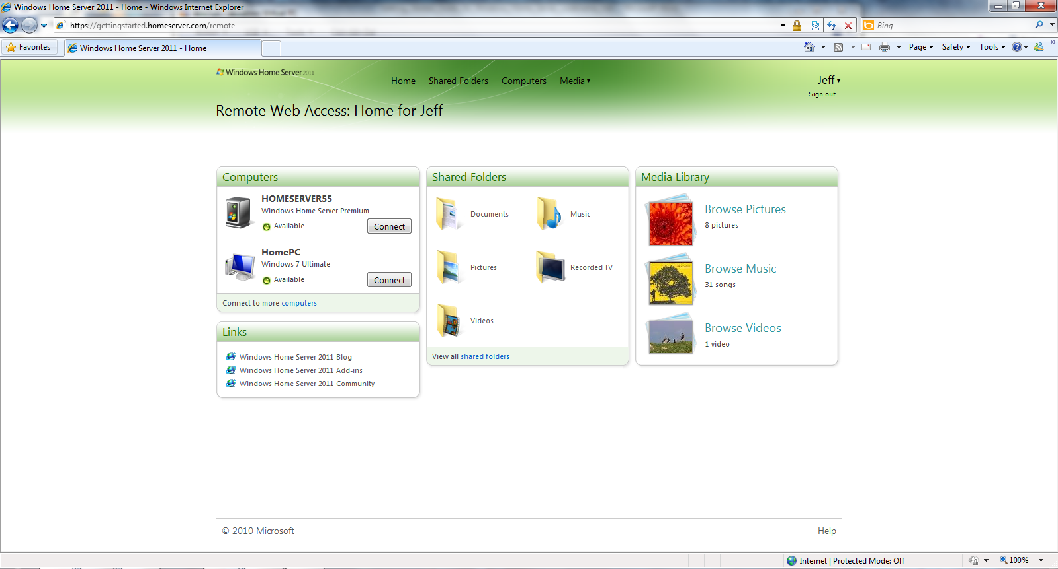

There are three things a user can do from the remote access interface:

• **Remote Access to Shared Folders**

Users can download files and folders, and upload one or more files to the shared folders on their home server while away from home. You can also search through the Shared Folders when you are trying to locate a specific file or files. Your files are on your home server and only authorized users can access them.

• **Remote Access to Home Computers**

Connect remotely to the computers in your home. Run an application as if you were sitting in front of your home computer.

• **Remotely Connect to the Windows Home Server 2011 Dashboard**

If the need arises, you can access the Windows Home Server 2011 Dashboard while away from home to add new users, add new shared folders or check the health of your home network.

To connect to one of your home computers, on the **Computers** tab, click the **Connect** button next to the home computer. You can only connect to a computer that is **Available for connection** and that is running one of the following operating systems:

* Windows XP Professional with Service Pack 3 (SP3)
* Windows Vista Ultimate, Windows Vista Business, or Windows Vista Enterprise with Service Pack 2 (SP2)
* Windows 7 Ultimate, Windows 7 Enterprise, Windows 7 Professional

**What makes Remote Access unique?**

* **Streaming Media**

With streaming media enabled through Remote Access, you can play your videos, music and pictures, when content is compatible.

* **Remote Access to Home Computers**

After logging into your home server, you can quickly connect to a home computer and run an application as if you were sitting in front of that computer.

• **Personalized Internet Address**

You can register for a personalized Internet address so that you can remotely access your home server in a highly secure manner using your personalized Internet address (e.g. [http://SmithFamily.HomeServer.com](http://SmithFamily.HomeServer.com/home)).

• **Remote access permissions set for each user**

You can define up to 10 users and for each user it is easy to enable or disable the ability to remotely connect to your home server. You can individually select to which options a user has Remote Access.

• **Windows Phone 7 access**

Your music, videos and pictures are available to your Windows Phone 7. With remote access enabled, you can stream, upload and download content while away from your home.

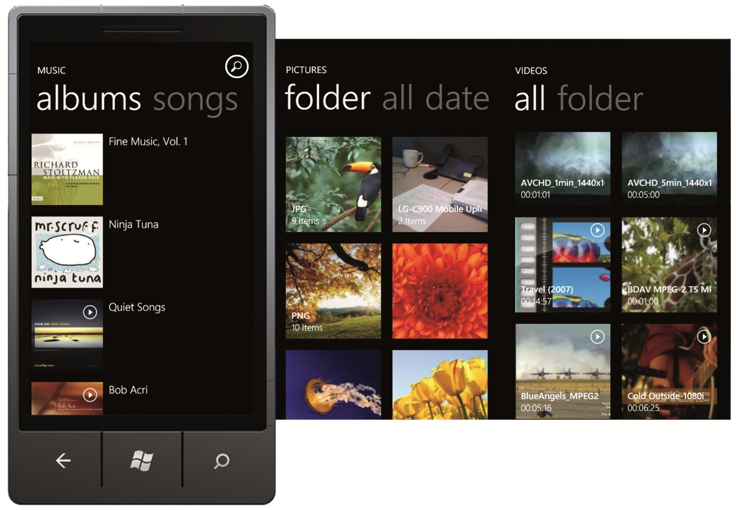

## Home Network Health Monitoring

WindowsHome Server monitors its own health status and the status of your computers that are running Windows XP, Windows Vista and Windows 7. Health status notifies you of any issues or problems that are found. Windows Home Server 2011 monitors the following health information:

* **Home Computer Backups**

Monitors that your home computers are being backed up on a regular basis and that the backups are completing successfully.

* **Server Storage and Shared Folders**

Monitors the hard drives in your home server and helps ensure that the shared folders have enough space on your hard disk drives and that shadow copies are working correctly.

* **Security Center Status for Windows 7, Windows Vista and Windows XP**

Collects the Security Center status from your home computers running Windows 7, Windows Vista and Windows XP, and helps you centrally monitor the health status of your computers from the Windows Home Server 2011 Dashboard.

* **Core Service and Low Disk Space Monitoring**Monitors key Windows services and the hard drives of your home computers. Displaying health alerts should available space on a particular hard drive fall below 10% and if a key Windows service has stopped.

The tray application provides you with a high-level indicator of the health of your home network. The icon can change to the following colors:

Description: cid:image004.png@01CBB402.F294E690 Green – your home network is healthy

Description: cid:image005.png@01CBB402.F294E690 Yellow – your home network is at risk

Description: cid:image002.png@01CBB402.F294E690 Red – your home server has found a critical problem

Description: cid:image001.png@01CBB402.F294E690 Blue – tray information such as backup

Description: cid:image003.png@01CBB402.F294E690 White – tray disconnected

If a problem is found, you can connect to the WindowsHome Server 2011 Dashboard to get more detailed information.

## Windows Home Server 2011 Dashboard

The Windows Home Server 2011 Dashboard is the application used to configure your home server. It is not intended to be used by everyone in the household.

You access the Dashboard from any computer that has the Windows Home Server Connector software installed by clicking Server Dashboard from the Launchpad. When you run the Dashboard application it will ask you for the home server password and then will connect to your home server.

The Windows Home Server 2011 Dashboard provides you the ability to:

• **View the Backup Status of your Home Computers**

The Computers and Backup tab allows you to view the backup status and configure backups on the computers where you have installed the Windows Home Server Connector software and your home server.

•    **Configure User Accounts**

The User Accounts tab allows you to add up to 10 user accounts, not including the Guest account. You can change the shared folders that users have access to and enable and define what level of remote access each user has.

• **Configure Shared Folders** **and Hard Drives**

The Shared Folders page allows you to add and remove shared folders and change properties of shared folders. If you have two or more storage devices in your home server, when you create a new folder, you can select which storage device you would like the shared folder to exist on.

The **Server Storage** page allows you to view hard drives attached to your home server for storage. You can see the status of your hard drives and attempt to repair any that show a status of ‘unhealthy’. You can view the total storage of your storage pool here as well.

• **View Health Alert Status of your Home Network**

The **Network Health** indicator provides you with healthy, at risk and critical health notifications for your home server and your home computers.

• **Add-ins**

Use the Add-ins tab to view, install and remove your current add-ins.

• Adjust Server Settings

You can change the configuration settings for your home server, such as: Windows Update settings, Media Streaming, HomeGroup, Remote Web Access and the date and time. Additionally, you will find the ability to restart your home server from the Dashboard settings.

## Partner Add-ins

Windows Home Server is based on the proven technologies of the Microsoft Windows Server® operating system and is designed to be a platform upon which other solutions can be developed. We’re excited to make available a new SDK for developers building add-ins for Windows Home Server 2011.

• **Your Home Server Can Do More**

Windows Home Server 2011 has been designed with extensibility in mind, so that software developers can develop innovative add-Ins, such as home web cameras, family information management software, home automation and home security solutions that work with your home server.

• **Large Ecosystem of Software and Hardware Partners**

Microsoft has partners throughout the world that have built and are continuing to build new software and hardware solutions that work with Microsoft Windows software. As these partners become familiar with Windows Home Server 2011, we will see solutions delivered that will enhance the usefulness and functionality of your home server.

Description: important_ddImportant

Be careful when selecting partner add-ins to install. If an add-in is not designed correctly for Windows Home Server 2011, it may cause harm. Check reviews on add-ins before using them.

# Resources

## Public Resources

### ****Windows Home Server blog:****

For more up to date news about Windows Home Server, please visit our blog! <http://go.microsoft.com/fwlink/?LinkId=188746>

### ****Windows Home Server public forums:****

If you need support, please visit our public forums where other community members can assist you in resolving any issues.   
<http://go.microsoft.com/fwlink/?LinkID=168988>

### ****Installation Instructions:****

For the most up to date installation instructions, please visit: <http://go.microsoft.com/fwlink/?LinkId=189714>

**For general help about Windows Home Server 2011:**  
<http://go.microsoft.com/FWLink/?LinkID=165674>

For the latest information on Windows Home Server, please visit the product web site at <http://go.microsoft.com/fwlink/?LinkId=100260>