Softtool manual

1. Appointment of buttons.

Run file RWCodeplug.exe.

Select Com port

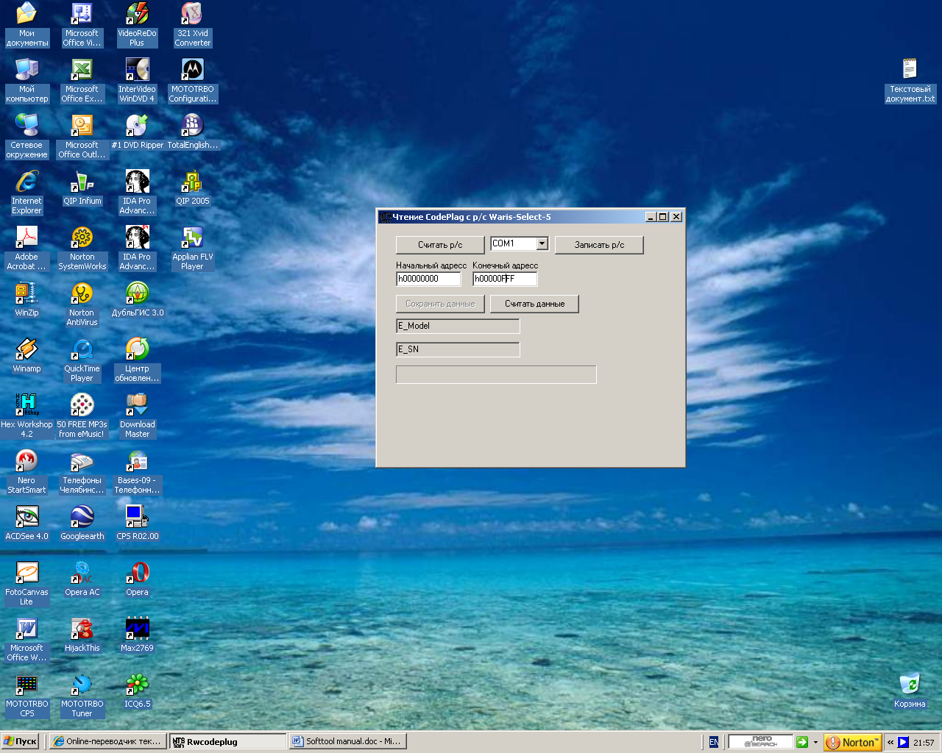
Read data
from radio
Write data
to radio

Save data
in file on disk
Get data
from file
“Start address” in eeprom for read/write data
“Stop address” in eeprom for read/write data

Model indicator

Serial number indicator

Bar indicator process

2. Procedure read and save data from radio.

Connect radio to PC with standard programming cable.

Close any other programs, which may use com ports.

Run file RWCodeplug.exe.

Select com port.

Establish Start address and Stop address for reading eeprom radio.
Recommendation: start address - 0000 / stop address - it is not less 3FFF
(depends on model radio, but in many cases of this address it is enough)

Press button “Read data from radio”.

Reading will begin, and “Bar indicator” will show process.

Probably, during the initial moment of time, to appear the message “Ошибка настройки порта 87” (error setting com port 87).
Press Ok and reading should proceed.
If reading has not begun, close / open the program and repeat attempt.

When reading to end to appear the message "Чтение завершено успешно" (reading is finished successfully).

“Model indicator” should show number of model of radio.

“Serial number indicator” should show SN of radio.

For save data on disk press button “Save data in file on disk”.
Place of save - folder ReadData.
Format file – mot.
The name of a file will look like Model – Serial number.
User can modify file name: text in line Model indicator can be corrected manually.

If softtool cannot define model number and/or serial number,
that in line “Model indicator” or “Serial number indicator” should show the message “Нет данных”.

3. Procedure read and save data from radio.

Press button “Get data from file” and select file codeplug in format mot.
Softtool automatically establish Start address and Stop address.
These data it will receive from selected codeplug file.
User can modify Start address / Stop address,
!!! Sottool doesn’t do any checks of correctness of written data.
Sottool only writes data in eeprom.
The error in selected file codeplug - way to destruction codeplug in radio.
User should understand, that it does!!!

For start write press button “Write data to radio”.

Probably, during the initial moment of time, to appear the message “Ошибка настройки порта 87” (error setting com port 87).
Press Ok and writing should proceed.
If reading has not begun, close / open the program and repeat attempt.

When writing to end to appear the message "Запись завершена успешно" (writing is finished successfully).

